Part1: Using available pre-trained models for object detection, conduct inference on a short video (5-10 seconds) of a street scene drawing bounding boxes around detected vehicles.

**Step 1.** Collect a source video. It may be necessary to divide the video into discrete image frames.

**Step 2.** Conduct inference on each frame of the video, drawing bounding boxes around detected vehicles.

**Step 3.** Format the results back into a video.

Use either Pytorch or Tensorflow.

Upload a .zip file containing your .ipynb notebook containing the code utilized and two video files: before inference (without bounding boxes) and after inference (with bounding boxes)

part 2:

Follow the steps in YOLOV8 and attach a screenshot of object detection.

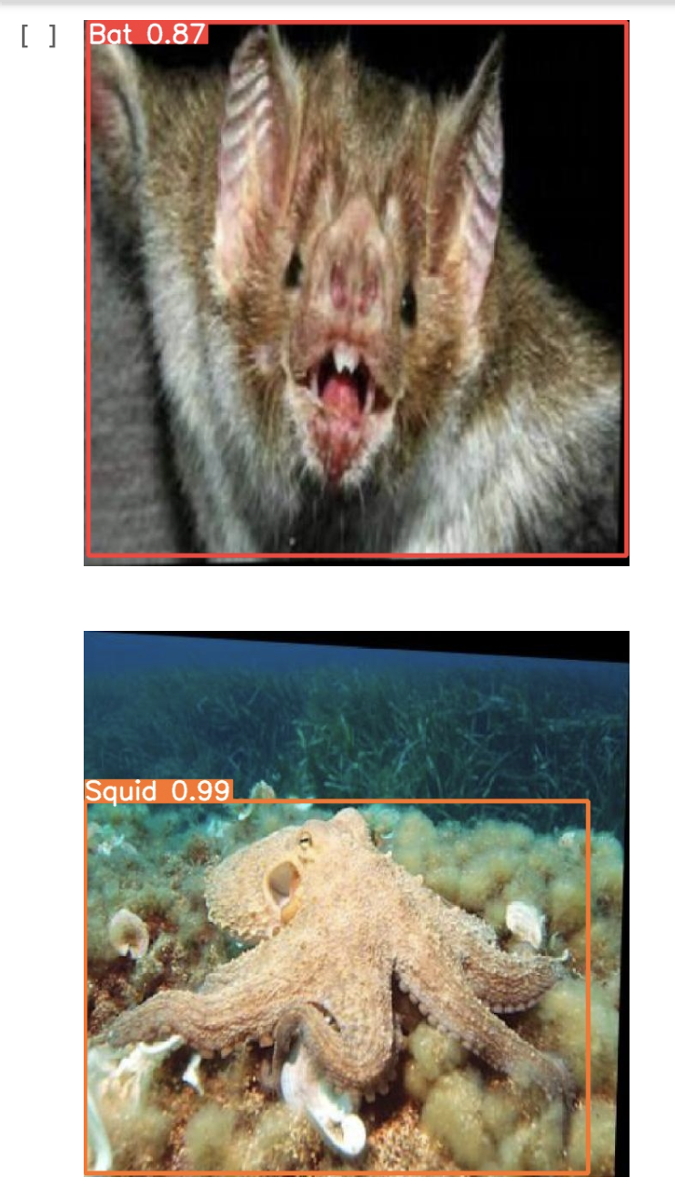

[Windows: https://medium.com/@pat.x.guillen/a-step-by-step-guide-to-running-yolov8-on-windows-122cb586b567](https://medium.com/@pat.x.guillen/a-step-by-step-guide-to-running-yolov8-on-windows-122cb586b567)

[Links to an external site.](https://medium.com/@pat.x.guillen/a-step-by-step-guide-to-running-yolov8-on-windows-122cb586b567)

Mac: <https://pysource.com/2023/03/28/object-detection-with-yolo-v8-on-mac-m1/>

[Links to an external site.](https://pysource.com/2023/03/28/object-detection-with-yolo-v8-on-mac-m1/)

buttery fly dataset: use ~10 images from

<https://universe.roboflow.com/yolo-a6y21/squid-bat-butterfly>

[Links to an external site.](https://universe.roboflow.com/yolo-a6y21/squid-bat-butterfly)

You can also try butterfly video and detect objects. (do not submit it)